How to setup com passthrough to enable wireless communication with no wireless (SERIAL COM ONLY) apps.

Install com0com https://com0com.sourceforge.net/
Go to the Sourceforge project page and download.

Make sure the default components are selected:
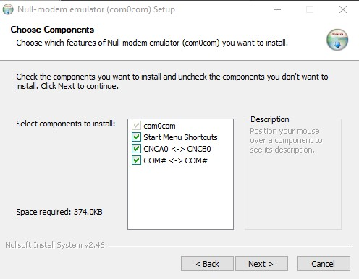

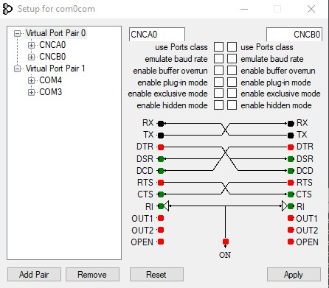
Launch setup and you should see something like this.

Note the COM ports under Virtual Port pair. In this case COM4 and COM3.
You want to get the following steps in order or else you may get COM connection errors.

- Start Tcode remote and select Serial as the Tcode input
- Select Network as the Output and enter your Tcode device address and port. (In most cases UDP should be used).
- You should see green checks like pictured below when all the devices are connected
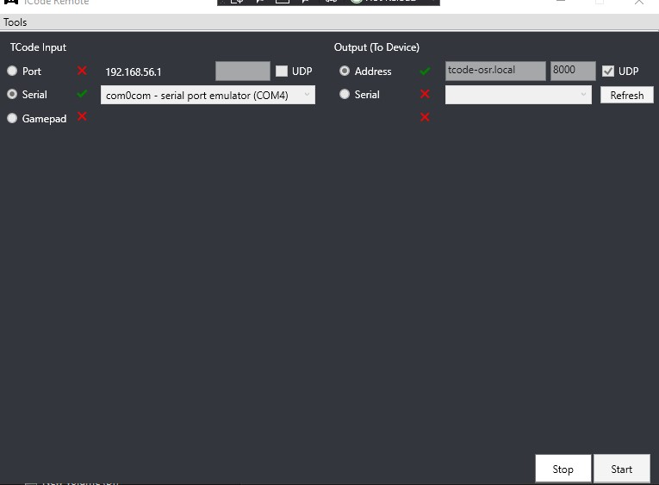
Click start after both devices connect

Open your application and select the other Com port in this case COM3

Your application should connect and now all data the application sends will pass through tcode remote to the Network output over UDP.

